**Technical Documentation**

**Architecture Overview**

The application is a WPF desktop app developed using C# and .NET 9.0. It follows a simple structure, with all logic contained within the MainWindow code for ease of use and understanding.

**Namespaces and Class Breakdown**

**Namespace:** FileMetaDataExplorer

**Classes:**

* **MainWindow**
  + Partial class combining MainWindow.xaml and MainWindow.xaml.cs
  + Handles UI logic, event interactions, and file data management
* **FileMetadata**
  + Properties:
    - FileName
    - FullPath
    - SizeKB
    - CreatedDate
    - ModifiedDate
    - Extension

**Key Methods**

* SelectFolder_Click  
  Opens a folder dialog, scans all files recursively, extracts metadata, and binds it to the DataGrid.
* ApplyFilters_Click  
  Filters the displayed file list based on file name, extension, and selected date range.
* RemoveFilters_Click  
  Clears all filters and resets the DataGrid to show all files again.
* ExportToCSV_Click  
  Saves the current filtered file list to a CSV file.
* ToggleDate_Click  
  Switches between filtering using CreatedDate and ModifiedDate.

**Pseudocode (Flow)**

Start

|

|-- User clicks "Select Folder"

| |

| |-- Open folder picker

| |-- Get all files in folder and subfolders

| |-- Extract metadata (name, size, dates, etc.)

| |-- Display data in the DataGrid

|

|-- User applies filters

| |

| |-- Read text, extension, and date inputs

| |-- Filter data using criteria

| |-- Update DataGrid with filtered list

|

|-- User exports to CSV

| |

| |-- Show save file dialog

| |-- Write filtered data to CSV

|

|-- User removes filters

| |

| |-- Reset input fields

| |-- Restore full file list

|

End

**User Manual**

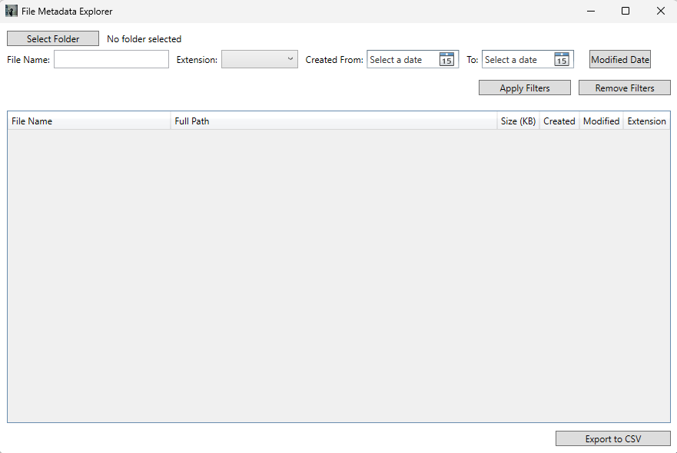

**Step 1: Select Folder**

* Click the **Select Folder** button.
* Use the dialog to pick a folder from your system.
* The application scans all files in that folder and subfolders.
* Metadata like name, path, size, created/modified date, and extension is shown in a table.

**Step 2: Apply Filters**

* Enter a partial file name in the text field (optional).
* Choose an extension from the dropdown (optional).
* Choose a date range using the two date pickers.
* Click **Apply Filters** to see matching files in the table.
* Use the **Modified Date** button to toggle filtering between creation and modification dates.

**Step 3: Remove Filters**

* Click **Remove Filters** to clear all fields and reset the table to show all files again.

**Step 4: Export to CSV**

* Click **Export to CSV**.
* Choose a destination using the save dialog.
* The filtered list can be saved as a .csv file at the chosen location.

